**Front-End UI/UX Mini Project**

**1. Title Page**

* **Project Title**: *My Favorite City*
* **Name:** ALVIN JOBI , JOSHUA SANTOSH , JOSEPH MANGALY , SAVIO JOSE
* **Reg. No.:** 2463005 , 2463032 , 2463031 , 2463051
* **Program:** B.Tech in Artificial Intelligence and Machine Learning
* **Semester:** 3rd
* **Institution:** Christ University, Kengeri
* **Academic Year:** 2025

**2. Abstract**

This project presents the design and development of an informative and visually engaging website titled "My Favourite City: Cochin." The website is created to introduce users to the cultural, historical, and modern highlights of Cochin, Kerala. Built with HTML and CSS, the site showcases best practices in web design with an emphasis on usability, accessibility, and aesthetic appeal. Key features include sections on city introduction, top attractions, restaurants, local events, and practical travel information, all integrated into a unified and responsive layout. The project demonstrates not only technical proficiency in front-end development but also the ability to convey the essence of a city through intuitive content structure and interactive visual design. This website aims to serve as an engaging guide for tourists, students, and locals interested in exploring Cochin’s unique charm and lifestyle.

**3. Objectives**

**The primary goals of this project are:**

* **Design an engaging informational city website using modern UI/UX principles to enhance visitor experience and showcase city highlights.**
* **Create a fully responsive layout using semantic HTML5 and CSS to ensure accessibility across desktops, tablets, and smartphones.**
* **Structure content into informative sections: Introduction, Attractions, Food & Cafes, Activities, Local Events, and Contact Information.**
* **Apply visually appealing and consistent CSS styling to reinforce the city's identity and improve readability.**
* **Ensure accessibility, clarity, and usefulness for a diverse range of users, including tourists and residents interested in Cochin.**

**4. Scope of the Project**

* The website focuses exclusively on front-end design and presentation, aiming to introduce, inform, and engage users about the selected city (e.g., Cochin) through immersive sections: Introduction, Attractions, Food and Cafes, Things to Do, Local Events, and Contact Information.
* The scope is limited to static, client-side web development, without use of JavaScript or server-side programming. Features such as content updates, interactions, and responsiveness are achieved entirely using HTML5 and CSS3.
* The website is designed to be fully responsive, adapting its appearance and layout across desktops, tablets, and smartphones to ensure accessibility for all users.
* Open-source technologies and tools are prioritized, with no reliance on external commercial libraries or frameworks. All code is original, using only HTML and CSS.
* This project does not cover backend integration, dynamic databases, or interactive scripting beyond HTML/CSS capabilities. Its purpose is to serve as a digital showcase and informational guide for the chosen city.

**5. Tools & Technologies Used**

|  |  |
| --- | --- |
| **HTML5** | **Content structure and semantic markup** |
| **CSS3** | **Styling, layout, and responsive design** |
| **Bootstrap 5** | **Responsive grid, UI components, modals, buttons, and styling** |
| **JavaScript** | **Enables interactivity and dynamic behaviors (via Bootstrap)** |
| **jQuery** | **Dependency for Bootstrap’s JS components and DOM manipulation** |
| **VS Code** | **Code editor for writing and managing project files** |
| **Chrome DevTools** | **Testing, debugging, and previewing the site behavior** |

**6. HTML Structure Overview**

* The project uses semantic HTML5 elements such as <header>, <section>, <article>, and <footer> for meaningful page organization.
* Content is divided into distinct sections: Introduction, Popular Attractions, Restaurants & Cafes, Things to Do, Local Events, and Contact Information.
* Bootstrap grid classes (e.g., .container, .row, .col-md-4) structure page layout responsively.
* Interactive elements like dropdowns use form controls (<select>) enhanced by jQuery and Bootstrap JavaScript.
* Images and maps are embedded with accessible alt attributes and styled for responsive scaling.

**7. CSS Styling Strategy**

* The site employs a cohesive color palette with gradients and shadows to create depth and visual interest.
* Custom CSS uses modern typography with Google Fonts to enhance readability and style.
* CSS transitions and transformations on hover provide subtle animations to images, cards, and sections for improved interactivity.
* Responsive design principles ensure the layout adapts from large screens to mobile devices using Bootstrap’s grid system and media queries.
* Consistent padding, margin, and border-radius values unify the look across components.

**8. Key Features**

* Detailed, visually rich presentation of city highlights and local attractions with descriptive text and images.
* Interactive dropdown lets users select activities, dynamically displaying related images via jQuery manipulation.
* Embedded interactive OpenStreetMap showing key city areas.
* Highlighted local events with styled badges for visual emphasis.
* Contact section with multiple contact methods and external tourism website links.
* Fully responsive layout ensuring usability on all screen sizes.

**9. Challenges Faced & Solutions**

* **Challenge: Ensuring responsiveness across diverse devices and browsers.  
  Solution: Leveraged Bootstrap grid and responsive utilities combined with thorough cross-browser testing using Chrome DevTools.**
* **Challenge: Dynamic image updates based on user dropdown selection to improve UX.  
  Solution: Used jQuery event handling to listen for dropdown change events and update the DOM with the appropriate content.**
* **Challenge: Maintaining accessibility while using interactive components.  
  Solution: Proper use of semantic HTML elements, descriptive alt text for images, and keyboard-navigable form controls.**

**10. Outcome**

* The project delivered an intuitive, visually appealing, and informative website about the favourite city, meeting all functional and design objectives.
* Users can explore the city’s culture, attractions, food, and events seamlessly on any device.
* The website demonstrates strong front-end skills with effective use of Bootstrap, HTML5, CSS3, JavaScript, and jQuery.

**11. Future Enhancements**

* Implement backend integration to allow dynamic updates of events and activities via a CMS or database.
* Add user authentication for personal trip planning features and saved favorite places.
* Enhance accessibility further by conducting audits and improving ARIA roles and keyboard navigation.
* Integrate maps with live navigation and location-based services via APIs like Google Maps.
* Add features like reviews and ratings for attractions and restaurants.
* Improve SEO optimizations to increase discoverability by search engines.

**12. Sample Code**

**<!DOCTYPE html>**

**<html lang="en">**

**<head>**

**<meta charset="UTF-8">**

**<meta name="viewport" content="width=device-width, initial-scale=1.0">**

**<title>Favorite City: Cochin</title>**

**<link href="https://cdn.jsdelivr.net/npm/bootstrap@5.3.0/dist/css/bootstrap.min.css" rel="stylesheet">**

**<script src="https://code.jquery.com/jquery-3.6.0.min.js"></script>**

**<script src="https://cdn.jsdelivr.net/npm/bootstrap@5.3.0/dist/js/bootstrap.bundle.min.js"></script>**

**<style>**

**body {**

**background: linear-gradient(135deg, #a1c4fd 0%, #c2e9fb 100%);**

**min-height: 100vh;**

**font-family: 'Poppins', 'Segoe UI', Arial, sans-serif;**

**}**

**h1 {**

**color: #1a237e;**

**font-weight: 800;**

**letter-spacing: 2px;**

**text-shadow: 0 2px 12px #c2e9fb;**

**}**

**h2 {**

**color: #3949ab;**

**font-weight: 700;**

**margin-bottom: 1.2rem;**

**}**

**.section {**

**background: linear-gradient(120deg, #fff 80%, #e3f2fd 100%);**

**border-radius: 20px;**

**box-shadow: 0 8px 32px rgba(33, 150, 243, 0.12);**

**margin-bottom: 2.5rem;**

**padding: 2.5rem 2rem;**

**transition: box-shadow 0.3s, transform 0.3s;**

**}**

**.section:hover {**

**box-shadow: 0 16px 48px rgba(33, 150, 243, 0.18);**

**transform: translateY(-2px) scale(1.01);**

**}**

**.attraction-img {**

**width: 100%;**

**border-radius: 14px;**

**margin-bottom: 1rem;**

**box-shadow: 0 2px 12px #a1c4fd55;**

**transition: box-shadow 0.3s, transform 0.3s;**

**}**

**.attraction-img:hover {**

**box-shadow: 0 8px 32px #3949ab33;**

**transform: scale(1.04);**

**}**

**.restaurant-card {**

**border-radius: 14px;**

**box-shadow: 0 2px 12px #a1c4fd55;**

**background: linear-gradient(100deg, #fff 80%, #e3f2fd 100%);**

**transition: box-shadow 0.3s, transform 0.3s;**

**}**

**.restaurant-card:hover {**

**box-shadow: 0 8px 32px #a1c4fd99;**

**transform: scale(1.03);**

**}**

**.event-badge {**

**background: linear-gradient(90deg, #a1c4fd 60%, #c2e9fb 100%);**

**color: #3949ab;**

**font-weight: 700;**

**font-size: 1rem;**

**margin: 0.2rem 0.5rem 0.2rem 0;**

**padding: 0.5em 1em;**

**border-radius: 8px;**

**box-shadow: 0 2px 8px #a1c4fd33;**

**}**

**#activitySelect {**

**font-size: 1.1rem;**

**border-radius: 8px;**

**box-shadow: 0 2px 8px #c2e9fb33;**

**}**

**#activityImage img {**

**border: 3px solid #a1c4fd;**

**box-shadow: 0 4px 24px #3949ab22;**

**}**

**ul, li {**

**font-size: 1.08rem;**

**}**

**@media (max-width: 600px) {**

**.section { padding: 1rem; }**

**h1 { font-size: 2rem; }**

**h2 { font-size: 1.2rem; }**

**}**

**</style>**

**</head>**

**<body>**

**<div class="container py-4">**

**<h1 class="mb-4 text-center">Discover Cochin</h1>**

**<!-- Introduction -->**

**<div class="section">**

**<h2>Introduction</h2>**

**<p>Cochin (Kochi), the Queen of the Arabian Sea, is a vibrant port city in Kerala, India. Known for its rich history, diverse culture, and scenic beauty, Cochin blends colonial architecture, backwaters, and modern city life.</p>**

**<ul>**

**<li>Population: ~2.1 million</li>**

**<li>Language: Malayalam, English</li>**

**<li>Currency: Indian Rupee (₹)</li>**

**</ul>**

**</div>**

**<!-- Attractions -->**

**<div class="section">**

**<h2>Popular Attractions</h2>**

**<div class="row g-4">**

**<div class="col-md-4">**

**<img src="images/fort.jpeg" class="attraction-img" alt="Fort Kochi Beach">**

**<h5>Fort Kochi Beach</h5>**

**<p>Historic beach famous for Chinese fishing nets and colonial buildings.</p>**

**</div>**

**<div class="col-md-4">**

**<img src="images/palace.jpeg" class="attraction-img" alt="Mattancherry Palace">**

**<h5>Mattancherry Palace</h5>**

**<p>Portuguese palace with Kerala murals and royal artifacts.</p>**

**</div>**

**<div class="col-md-4">**

**<img src="images/jews.jpeg" class="attraction-img" alt="Jewish Synagogue">**

**<h5>Jewish Synagogue</h5>**

**<p>Oldest active synagogue in the Commonwealth, built in 1568.</p>**

**</div>**

**</div>**

**<div class="mt-4">**

**<iframe src="https://www.openstreetmap.org/export/embed.html?bbox=76.233%2C9.963%2C76.267%2C9.987&amp;layer=mapnik" style="width:100%;height:300px;border-radius:10px;border:none;"></iframe>**

**</div>**

**</div>**

**<!-- Restaurants and Cafes -->**

**<div class="section">**

**<h2>Best Restaurants & Cafes</h2>**

**<div class="row g-3">**

**<div class="col-md-6">**

**<div class="card restaurant-card p-3">**

**<h5><a href="https://www.google.com/maps/search/?api=1&query=Kashi+Art+Cafe+Fort+Kochi" target="_blank" class="btn btn-outline-primary btn-sm restaurant-link">Kashi Art Cafe</a></h5>**

**<p>Cuisine: Continental, Cafe | Rating: 4.6 | Location: Fort Kochi</p>**

**</div>**

**</div>**

**<div class="col-md-6">**

**<div class="card restaurant-card p-3">**

**<h5><a href="https://www.google.com/maps/search/?api=1&query=Dhe+Puttu+Edappally" target="_blank" class="btn btn-outline-primary btn-sm restaurant-link">Dhe Puttu</a></h5>**

**<p>Cuisine: Kerala, South Indian | Rating: 4.5 | Location: Edappally</p>**

**</div>**

**</div>**

**<div class="col-md-6">**

**<div class="card restaurant-card p-3">**

**<h5><a href="https://www.google.com/maps/search/?api=1&query=Ginger+House+Restaurant+Mattancherry" target="_blank" class="btn btn-outline-primary btn-sm restaurant-link">Ginger House Restaurant</a></h5>**

**<p>Cuisine: Indian, Seafood | Rating: 4.7 | Location: Mattancherry</p>**

**</div>**

**</div>**

**</div>**

**</div>**

**<!-- Things to Do -->**

**<div class="section">**

**<h2>Things to Do</h2>**

**<div class="mb-3">**

**<label for="activitySelect" class="form-label">Select an Activity</label>**

**<select class="form-select" id="activitySelect">**

**<option value="">Choose...</option>**

**<option value="houseboat">Houseboat Ride in Backwaters</option>**

**<option value="marine">Explore Marine Drive Promenade</option>**

**<option value="lulu">Visit Lulu Mall for Shopping</option>**

**<option value="kathakali">Watch Kathakali Performances</option>**

**<option value="cherai">Relax at Cherai Beach</option>**

**</select>**

**</div>**

**<div id="activityImage" class="mt-3"></div>**

**</div>**

**<script>**

**const activityImages = {**

**houseboat: {**

**src: "images/houseboat.jpeg",**

**alt: "Houseboat Ride in Backwaters"**

**},**

**marine: {**

**src: "images/marine.jpeg",**

**alt: "Marine Drive Promenade"**

**},**

**lulu: {**

**src: "images/lulu.jpeg",**

**alt: "Lulu Mall Shopping"**

**},**

**kathakali: {**

**src: "images/kath.jpeg",**

**alt: "Kathakali Performance"**

**},**

**cherai: {**

**src: "images/cherai.jpg",**

**alt: "Cherai Beach"**

**}**

**};**

**$('#activitySelect').change(function() {**

**let val = $(this).val();**

**if(activityImages[val]) {**

**let img = activityImages[val];**

**$('#activityImage').html(`<img src="${img.src}" alt="${img.alt}" class="attraction-img" style="max-width:400px"><div class="mt-2">${img.alt}</div>`);**

**} else {**

**$('#activityImage').html("");**

**}**

**});**

**</script>**

**<!-- Local Events -->**

**<div class="section">**

**<h2>Local Events</h2>**

**<span class="badge event-badge">Cochin Carnival - December/January</span>**

**<span class="badge event-badge">Biennale Art Festival - December-March</span>**

**<span class="badge event-badge">Onam Festival - August/September</span>**

**<span class="badge event-badge">Indira Gandhi Boat Race - December</span>**

**</div>**

**<!-- Contact Information -->**

**<div class="section">**

**<h2>Contact Information</h2>**

**<p>For local tours or hotel bookings:</p>**

**<ul>**

**<li>Email: info@cochintours.com</li>**

**<li>Phone: +91 484 1234567</li>**

**<li>Website: <a href="https://www.kochitourism.org/" target="_blank">Kochi Tourism</a></li>**

**</ul>**

**</div>**

**</div>**

**</body>**

**</html>**

**13. Screenshots of Final Output**

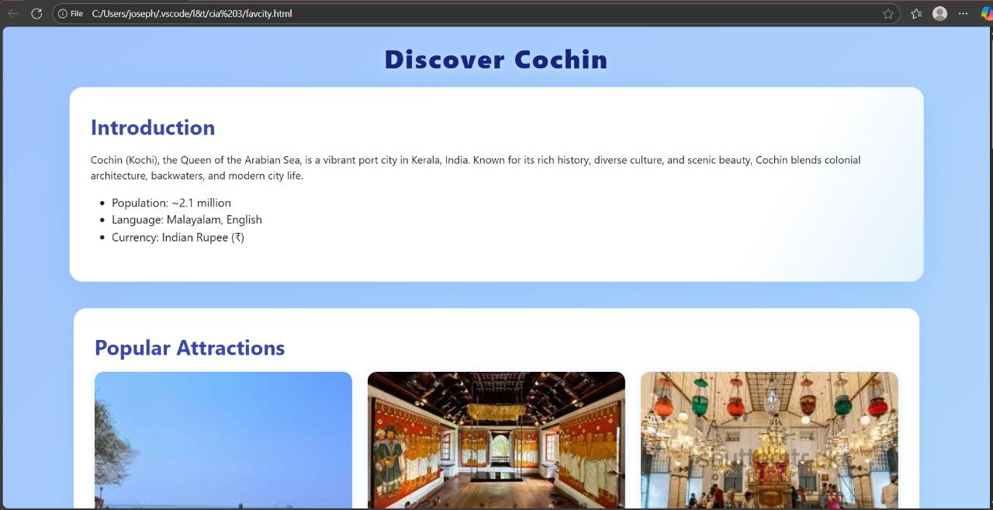

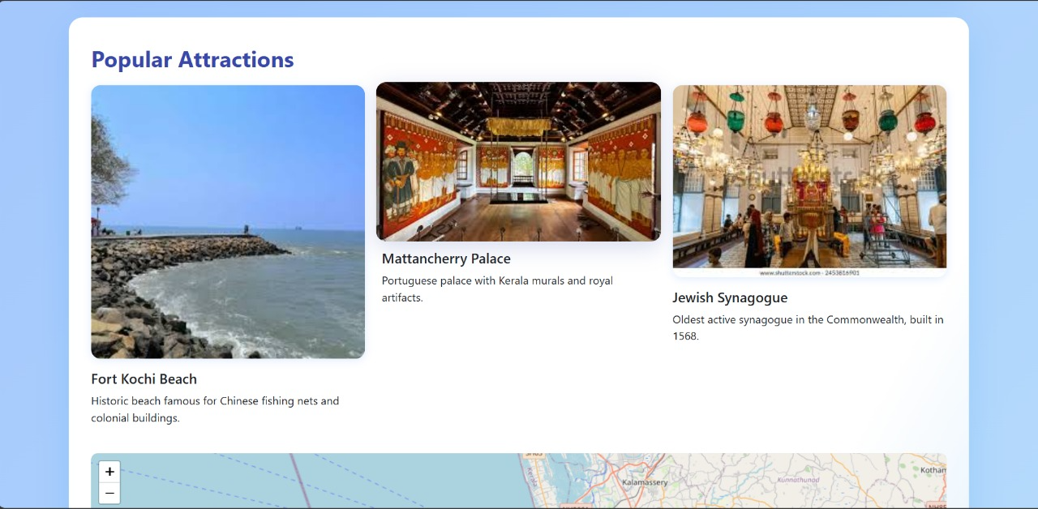

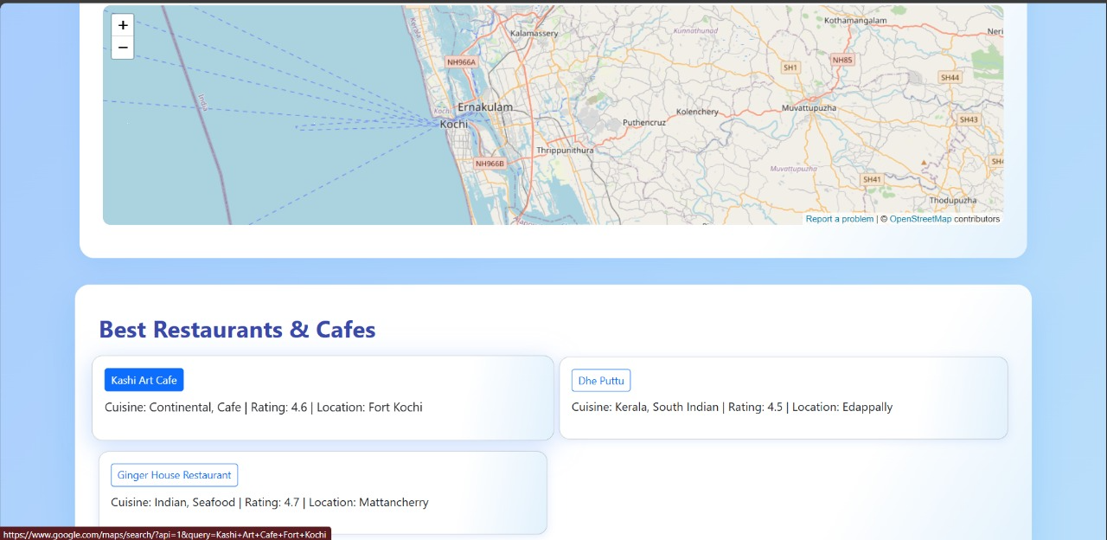

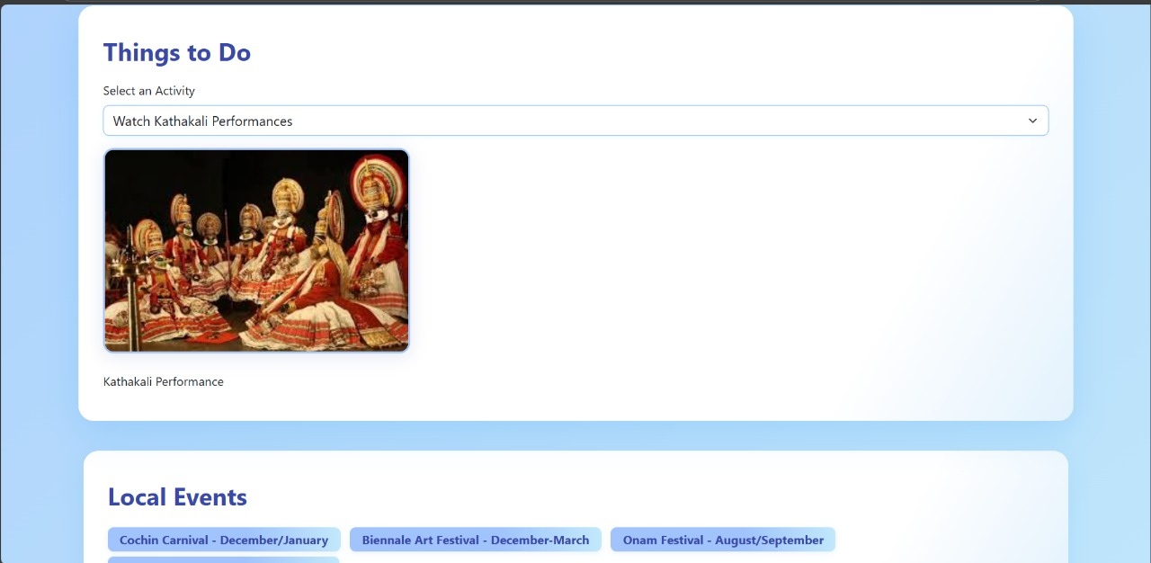

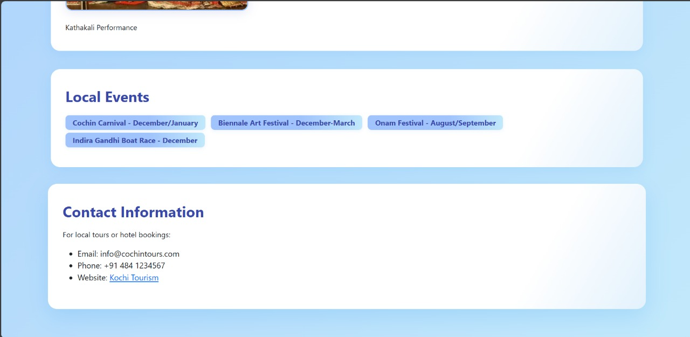

**14. Conclusion**

The "My Favourite City" website project successfully demonstrates the creation of an engaging, informative, and visually appealing digital guide for the city of Cochin. By utilizing modern web technologies including HTML5, CSS3, Bootstrap, JavaScript, and jQuery, the project delivers a responsive and user-friendly experience across multiple devices. The site effectively highlights the city’s rich cultural heritage, popular attractions, local events, and dining options in a structured and accessible manner. This project not only reinforces foundational front-end development skills but also showcases how thoughtful design and interactivity can enhance user engagement. Going forward, the project lays a solid foundation for further enhancements like dynamic content integration, personalized user features, and accessibility improvements, making it a valuable resource for tourists and residents alike.

**15. References**

1. W3Schools. (2025). HTML5 Tutorial. Retrieved September 2025, from <https://www.w3schools.com/html/>
2. W3Schools. (2025). CSS3 Tutorial. Retrieved September 2025, from <https://www.w3schools.com/css/>
3. Bootstrap Documentation. (2025). Bootstrap 5. Retrieved September 2025, from <https://getbootstrap.com/docs/5.3/getting-started/introduction/>
4. jQuery Foundation. (2025). jQuery API Documentation. Retrieved September 2025, from <https://api.jquery.com/>
5. OpenStreetMap contributors. (2025). OpenStreetMap. Retrieved September 2025, from <https://www.openstreetmap.org/>
6. Kerala Tourism. (2025). Cochin - The Queen of Arabian Sea. Retrieved September 2025, from <https://www.keralatourism.org/destination/kochi/>
7. Google Fonts. (2025). Poppins Font. Retrieved September 2025, from <https://fonts.google.com/specimen/Poppins>